**Extra Credit Program**

CS2010 30 pts

Spring, 2018 Due: 11:59 pm, Wednesday, April 25, 2018

This assignment will give you practice with *while* loops covered in Chapter 5 of the Gaddis textbook. It has two parts. Create a new Visual C++ project for each part.

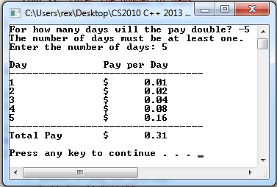**Part A** – 14 points.

Write a complete C++ program to solve Programming Challenge 7 on page 294 in your textbook. Be sure to validate the input as described. You **must use a *while* loop**. Here is a sample run of the program.

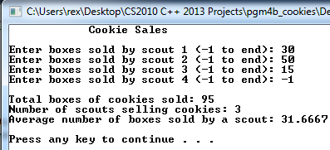**Part B** – 16 points.

Your local scout troop is selling cookies. The troop leader would like you to write a program that accepts the number of boxes of cookies sold by each scout and displays the following output:

- the total number of boxes sold by the troop

- the total number of scouts selling cookies

- the average number of boxes sold by a scout.

Write a complete C++ program that produces the desired output. **Hint**: Use a sentinel-controlled **while** loop.

A sample run of the program is shown.

Bonus: Find and display the highest number of boxes sold by a scout along with the scout's number. Given the input above, your output would look like this: *Most boxes of cookies sold was by scout 2 with 50 boxes.*

**Follow these steps for developing both Part A and Part B of the assignment.**

1. Follow the steps used for previous assignments (make sure you understand the problem, identify any constants and input/output variables, write the steps in the algorithm, etc.)

2. When you are ready to type in your program, create a new Visual C++ project using your last name, first initial and pgmexta (or pgmextb) as the project name and C++ file name (e.g., **LowJ_pgmextb** and **LowJ_pgmextb.cpp**).

3. Type in your header and inline comments (following guidelines for previous programs) and C++ statements.

4. Run, test and debug your program until it correctly displays the results.

5. When you are satisfied that your program is producing the correct output, turn in ONLY the .cpp file from each project on Canvas.

**CS2010 Grading Rubric - Extra Credit Program**

**Part A**

Project named correctly, .cpp file turned in on Canvas.

4 Header comments complete. In-line comments complete. Uses good program style (meaningful data names, whitespace, indentation).

2 User is prompted for input. Output is formatted and aligned in columns using <iomanip> include formatting features.

8 Generates correct output for specified inputs including error messages for invalid data.

**14 Total Points**

**Part B**

Project named correctly, .cpp file turned in on Canvas.

4 Header comments complete. In-line comments complete. Uses good program style (meaningful data names, whitespace, indentation).

2 User is prompted for inputs. Output is legible and reasonably formatted.

10 Generates correct output for specified inputs.

2 **Bonus** - Displays highest number of boxes sold by a scout along with the scout's number.

**16 Total Points**

**30 Extra Credit Program - Overall Total (32 with bonus)**